

INDIVIDUAL WORK

NAME: RUDRA NARAYAN BANJARA

Index

Flowchart.............................................................................................................................3

Contextual Inquiry Version 1 (Zillow Website): ......................................................................8

Contextual Inquiry Version 2 (Low Fidelity): ........................................................................16

Contextual Inquiry Version 3 (High Fidelity): .......................................................................24

Heuristic Evaluation on Satish’s Task (AirBnB website): .....................................................29

Heuristic Evaluation on Satish’s Task (Low Fidelity): ...........................................................33

Heuristic Evaluation on Satish’s Task (High Fidelity): ...........................................................36

**LOW FIDELITY DESIGN**

User or owner intends to LOGIN or else SIGN-UP for a new account in Living Excellence Website.

**STEP-1:** When user or owner wants to Login/Sign-up for their account in Living Excellence website, they click on LOGIN/SIGN-UP button.

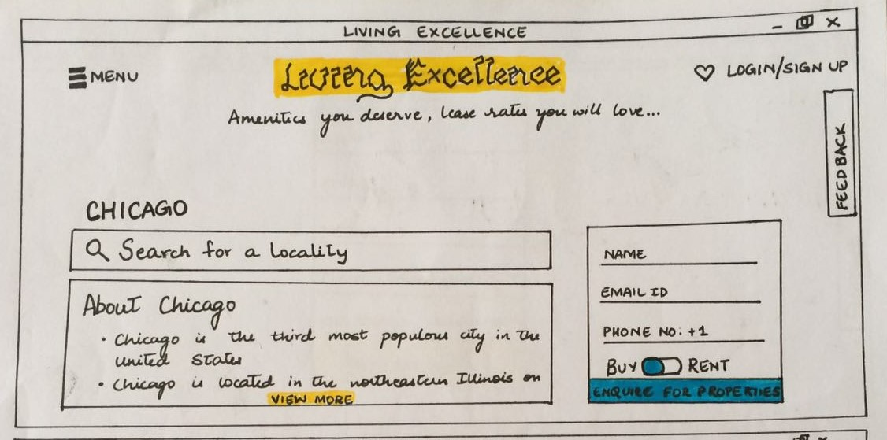

**STEP-2:** When user or owner clicks the Login/Sign-Up button present on the homepage of Living Excellence Website, they are redirected to the login page.

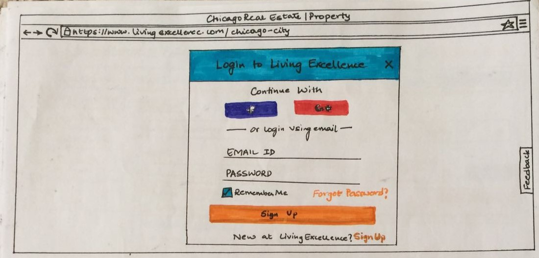

**STEP-3:** If the user or else owner don’t have already account created, they can sign-up and easily create their own account after clicking the Sign-up button present at the last of the login-page.

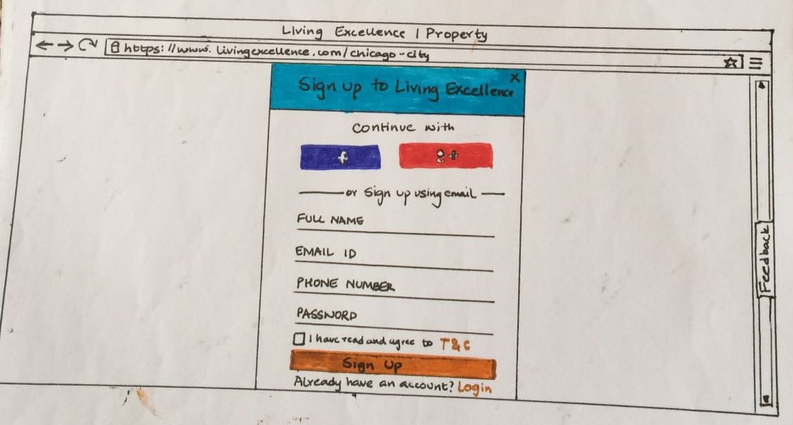

**STEP-4:** Once the user or owner after submitting the right credentials clicks gets signed in, now the user or user can login to their account. User or else owner or redirected to login page once again.



**STEP-5:** After entering the right credentials in the login page user get logged in to his/her own account created in the Living excellence website.

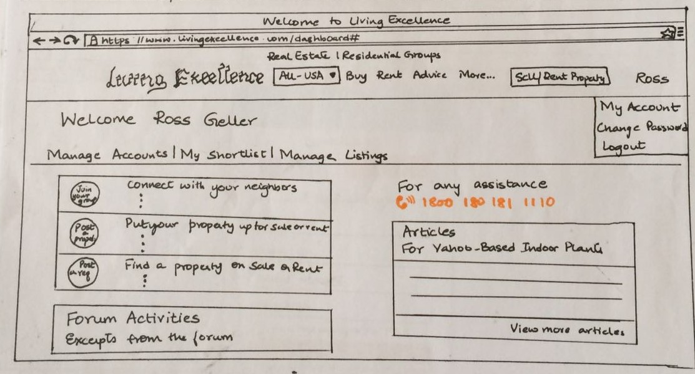

**STEP-6:** After entering the right credentials in the login page owner get logged in to his/her own account created in the Living excellence website.

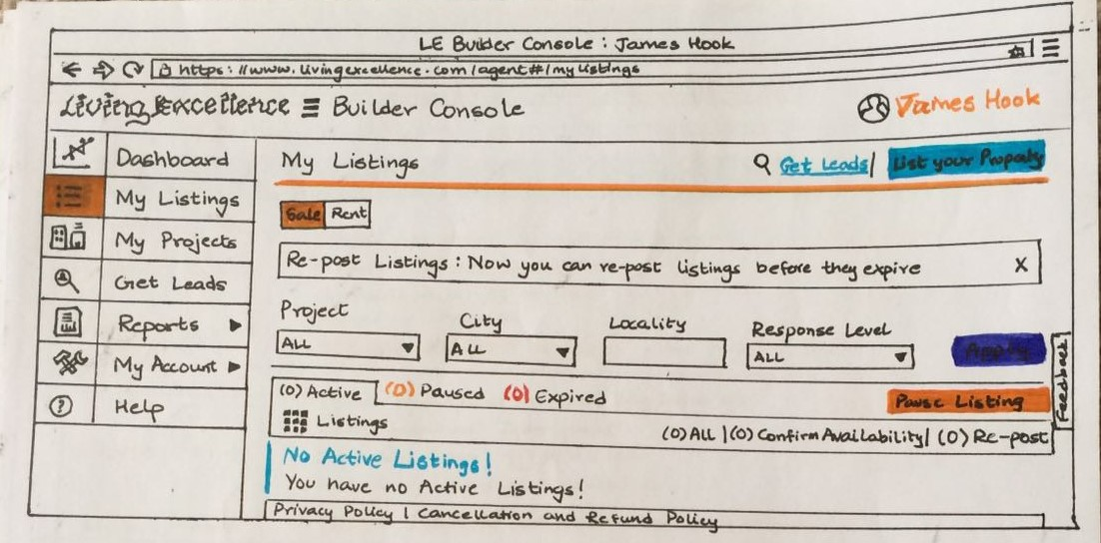

**STEP-7:** When the user or owner wants to logout from their account, they get logged out after clicking the logout button. Once they get logged out, user or owner gets redirected to login page of the Living Excellence website.

**FLOWCHART**

The flowchart explains the steps involved where customer and owner can either Login to their already created account or else Sign-up to create an account.

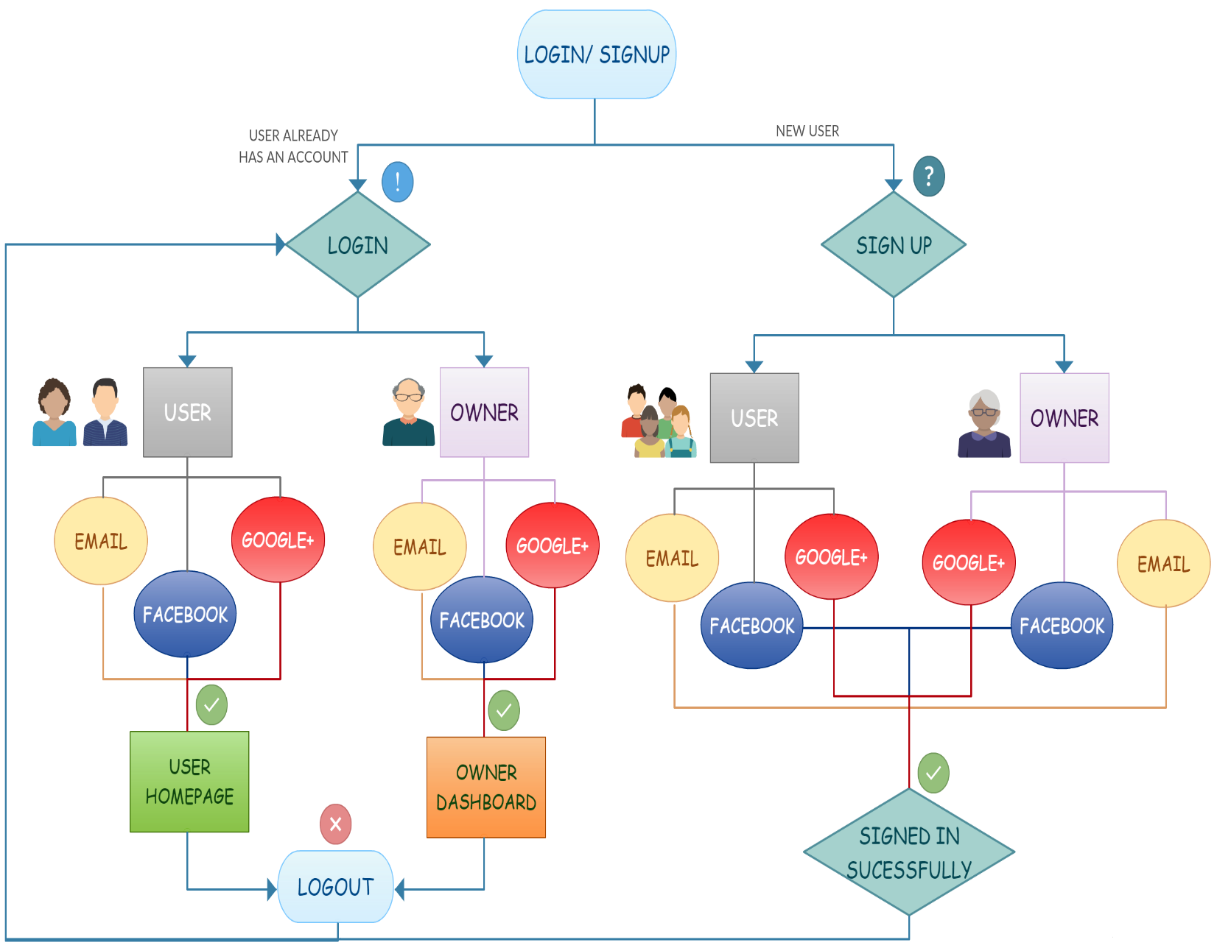

1. When user or owner lands the homepage of Living Excellence website and in order to either login to their individual account or else sign-up to create new account clicks the login/sign-up button.

2. The user or owner can either Login directly to their already created account or else Sign up to create an account.

3. The user or owner can Sign-up using their Facebook account, Email account or else Google+ account as well.

4. The user or else owner has to submit right credentials in the account sign up page in order to get signed in successfully.

5. The owner or user is redirected to the Sign-up page if the entered credentials are not proper or desired.

6. The user or owner after signing in successfully is redirected to the Login page.

7. The user or owner can Login using their Facebook account, Email account or else Google+ account.

8.Upon entering the right credentials by the user, user gets logged in to his/her own created account.

9. Upon entering the right credentials by the owner, owner gets logged in to his/her own dashboard page or account.

10. If the user or owner wants to logout from their homepage or dashboard, upon clicking the Logout button present in the top left corner of their homepage, the user or owner gets logged out.

11. When the user or owner logout, they are redirected to the login page of the Living Excellence website.

**CONTEXTUAL INQUIRY VERSION 1**

**User or owner can either Login to their already created account or else Sign-up to create a new account.**

**DESCRIPTION:** The user is asked to Sign-Up for a new account in <http://www.zillow.com/> and then login to his/her own created account with the following specification. The contextual inquiry is done based on the existing interface.

1. Email-id: [rudra28narayan@gmail.com](mailto:rudra28narayan@gmail.com) , [rudra1personal@gmail.com](mailto:rudra1personal@gmail.com)
2. Password: rudra12345, rudra67890

**STEPS INVOLVED:**

1. The first step involved in the process was to open the <http://www.zillow.com/> website in web browser.

2. Now, the user must click on the Sign-in button on the top right corner.

3. The user must click on the New Account link to create new account.

4. The user must enter the credentials provided to him or her to sign-in.

5. The user must click on Submit/ Sign-in button.

6. The user should now login to the account using the credentials provided for sign-in.

7. The user must click on the Sign-in button on the top right corner.

8. The user must enter the details to login.

9. The user must search for the logout button.

10. The user must click on logout button.

**User 1:**

**Persona of the user**

Name: Ajeenah Muhammad

Age: 34

Nationality : American

Job: Leasing Agent

Language used for conversation: English

Ajeenah Muhammad is the leasing agent for Prairie Shores Apartments located in South King Drive,Chicago. She has been working as a leasing agent from past 4 years in Prairie Shores. She has created many listings regarding availability of apartments and rooms for Prairie Shores Apartments and posted it in online on the website. Hence, I chose Ajeenah Muhammad as an example for performing the Contextual Inquiry.

**GOAL:** The user was asked to reach the final step in sign-in and then login in the site <http://www.zillow.com/> by providing a dummy account on the site.

**STEPS:**

1. The user was able to type the url in the web browser and opened the website easily.

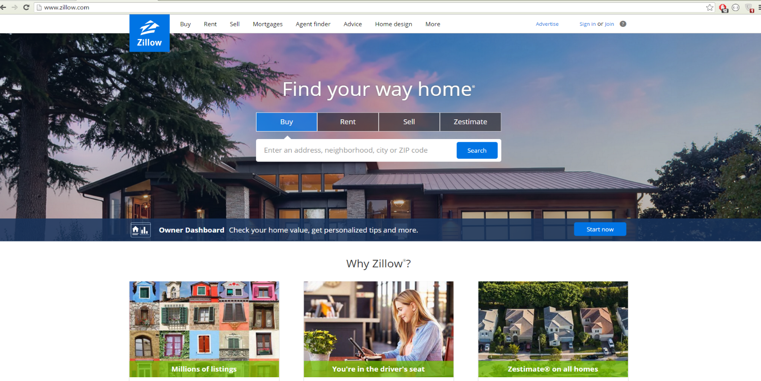

2. The user faced difficulty in the next step. The user had to search for login/sign-up button.

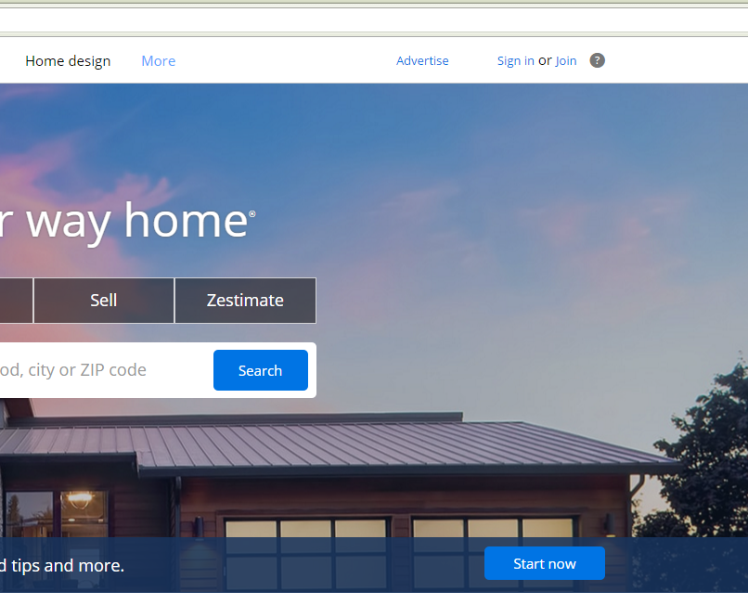

3. The user clicked on the Sign-in button.

4. The user felt little confused while searching for the Sign-in link or tab, later on figured it out and clicked on the New account tab.

5. After entering the credentials provided to the user, the user clicked on Submit button.

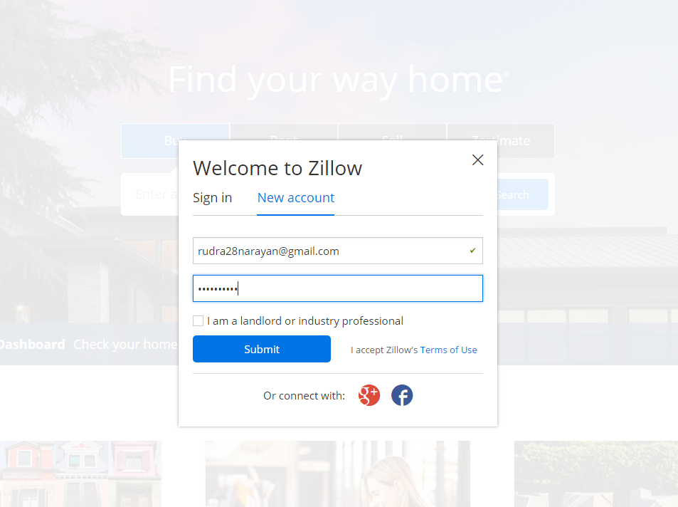

6. The user was not able to figure it out the login button after signing in, as it was not found.

7. Hence the user clicked on “My Zillow” link and entered to the user account created by the user.

8. The user was not able to figure it out the logout button to get logged out from her account.

9. The user clicked on Zillow icon to reach out of her user account.

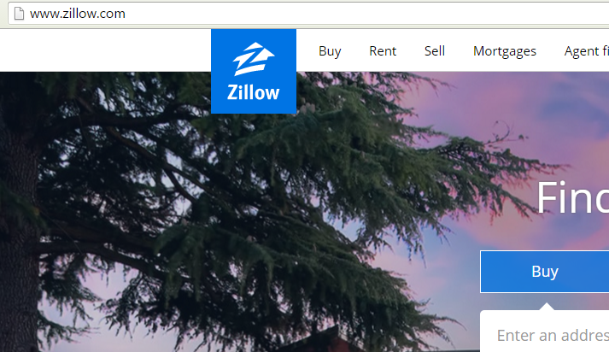

**STEPS DONE BY USER IN RIGHT WAY**

1. The user clicked on the “My Zillow” link when she was not able to find the login button.

**ISSUES FACED BY USER**

1. The user faced issues in finding the login button in the interface.

2. The user faced issues in finding the logout button on her user account main page.

**SUGGESTIONS RECEIVED FROM THE USER**

Ajeenah Muhammad suggested to reduce the redundant information in the site and reduce the number of tabs in the site. She also suggested to create a logout button the user main account page so that it should be visible clearly to the user whenever user wants to get logged out from her account.

**User 2:**

**Persona of the user**

Name: Juan Quintana

Age: 42

Nationality : Spain

Job: Product Analyst

Language used for conversation: English

Juan Quintana is the Product Analyst for Credence Systems Pvt. Ltd. located in West Eerie,Downtown Chicago. He has been working as a Product Analyst from past 7 years in above mentioned multinational company. He has created many prototypes for the products initially. He’s running his own startup in Spain as well. Hence, I finalized Juan Quintana as an example for performing the Contextual Inquiry after inerviewing many random users.

**GOAL:** The user was asked to reach the final step in sign-in and then login in the site <http://www.zillow.com/> by providing a dummy account on the site.

**STEPS:**

1. The first step involved in the process was to open the Zillow site on the web browser. User performed this task easily.

2. The user was asked to create a dummy account in the website. The user credentials were already provided to the user.

3. The user clicked on the Sign-in button on the top right corner confidently.



4. The user clicked on the Sign-in tab and entered the right credentials provided already.

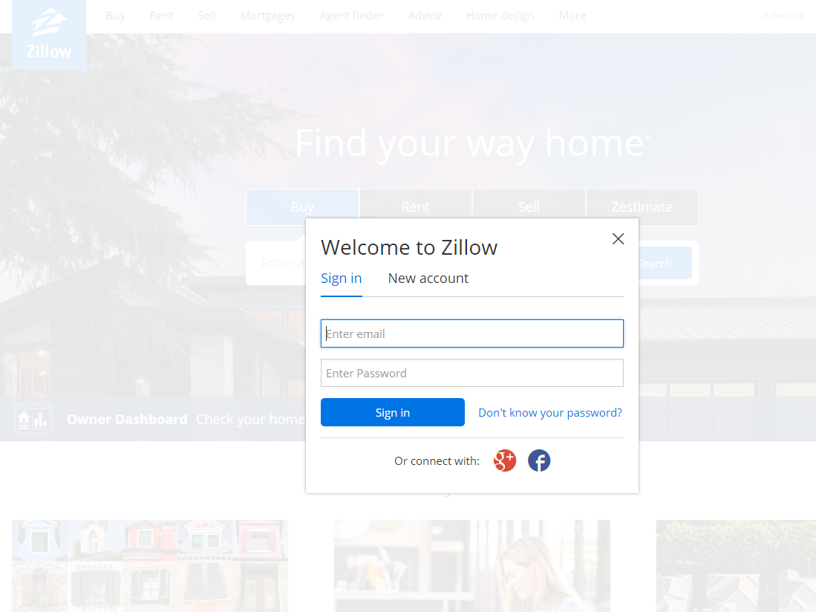

5. The user clicked on Sign-in button.

6. The user was redirected to his own account page after pressing the sign in button automatically.

7. The user clicked on My Zillow link to get logged out from the dummy account.

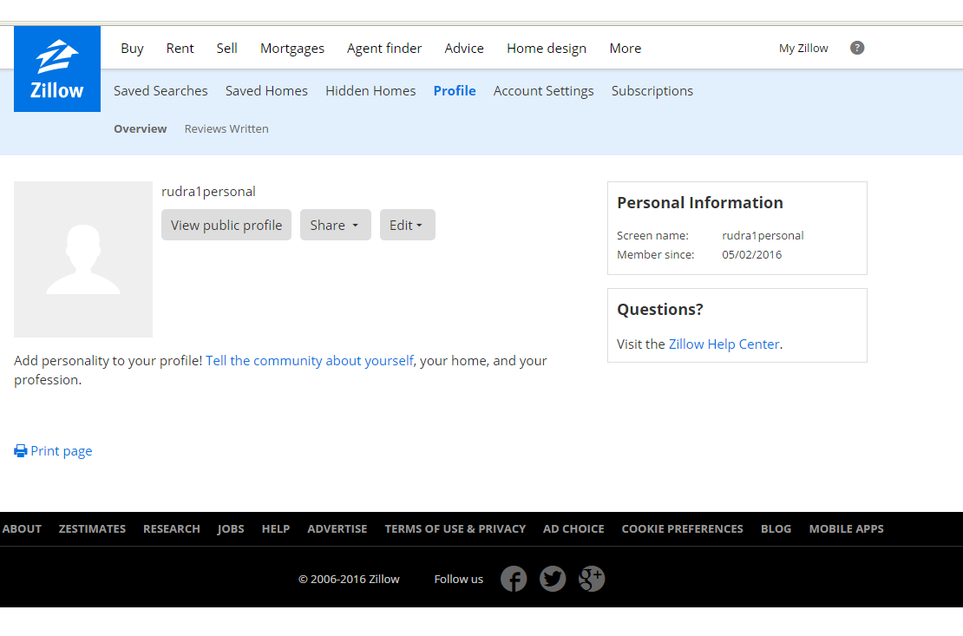

8. The user was not able to figure it out the logout button to get logged out from his dummy account.

9. The user clicked on various tabs in the dummy account but could not figure out how to get logged off from the dummy account.

10. The user pressed the back button of the browser to come out from his dummy account.

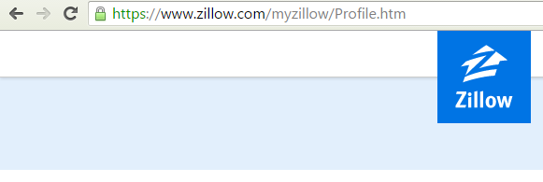

**STEPS DONE BY USER IN RIGHT WAY**

1. The user did all the steps in the process in the right way as expected.

**ISSUES FACED BY USER**

1. The user didn’t face any issues during the login and entering credentials but the user faced issues in finding the logout button on his dummy account.

**SUGGESTIONS RECEIVED FROM USER:**

Juan Quintana suggested to make the interface which I had planned to be similar to the <https://www.zillow.com/> as he found it very easy to use and he also didn’t face any difficulties in reaching the goal of the CI except the logout button.

Juan further suggested to add a logout button on the dummy account so that user can log off from his account successfully.

**CONTEXTUAL INQUIRY VERSION 2**

**User or owner can either Login to their already created account or else Sign-up to create a new account.**

**DESCRIPTION:** The user is asked to create a Login and Sign-Up page using the low fidelity prototype for the Living Excellence User Interface.

**User 1:**

**Persona of the user**

Name: Ajeenah Muhammad

Age: 34

Nationality : American

Job: Leasing Agent

Language used for conversation: English

Ajeenah Muhammad is the leasing agent for Prairie Shores Apartments located in South King Drive,Chicago. She has been working as a leasing agent from past 4 years in Prairie Shores. She has created many listings regarding availability of apartments and rooms for Prairie Shores Apartments and posted it in online on the website. Hence, I chose Ajeenah Muhammad as an example for performing the Contextual Inquiry.

**GOAL:** Ajeenah Muhammad as a user was asked to create a Login and Sign-up page using the low fidelity prototype (paper prototype) for the “Living Excellence – Amenities you deserve; lease rates you will love”.

**STEPS:**

1. Ajeenah suggested that she would search for the login button on the “Living Excellence” website’s home page or landing page. She also suggested that login button should be clearly visible to the user.

2. Later she suggested that she would create a login button on the homepage of Living Excellence itself.

3. After few seconds she indicated me that she would also create a new user button on the main page of the website so that new user can register themselves for the services provided by Living Excellence.

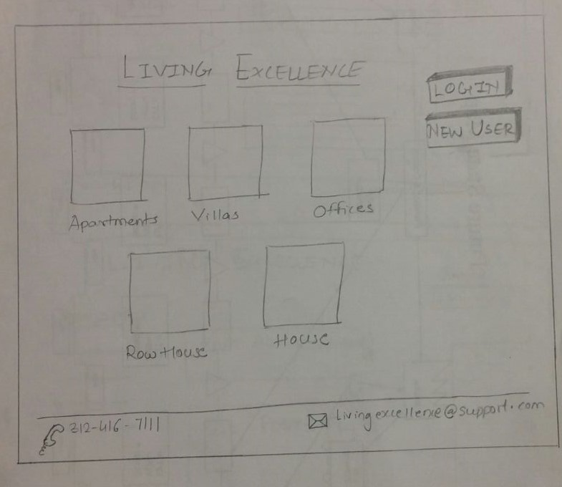

4. The user suggested that she would create an another page for Login so that when a user clicks on login button he or she will be redirected to the login page.

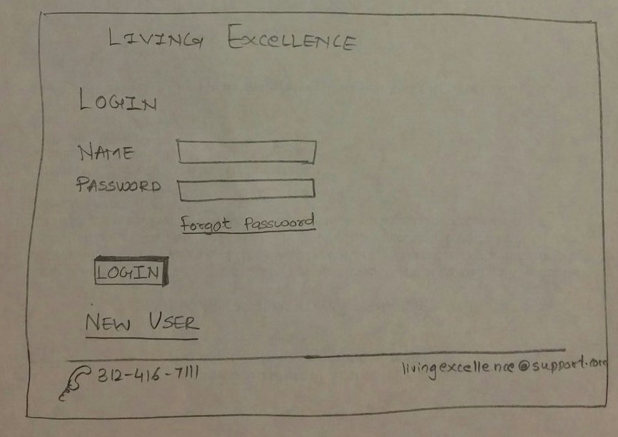

5. Ajeenah was very quick in her thoughts, later on she proposed that she would create a Sign up page for a new user. When user clicks on New user button, user will be redirected to the Sign up page.

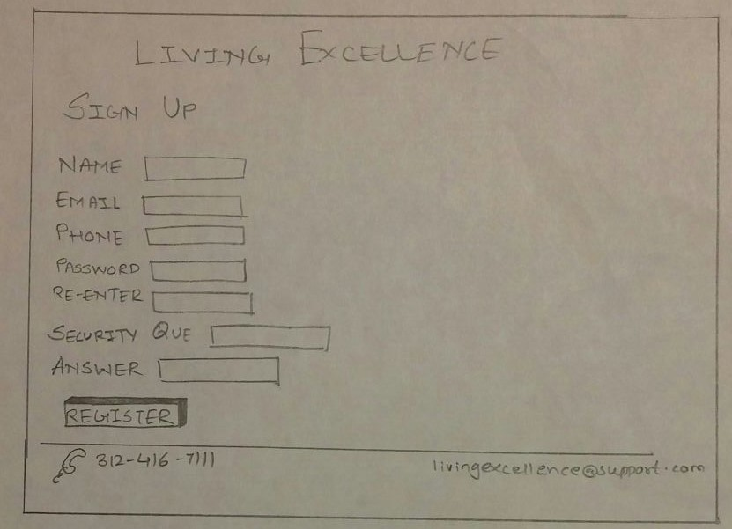

6. The user suggested that when the user successfully signed up, the user will be redirected to the login page once again and after entering the right credentials, the user will be successfully logged in.

7. Ajeenah Muhammad indicated that when a user logged in to the account created by him or her, he will be able to see all the information present in the user page.

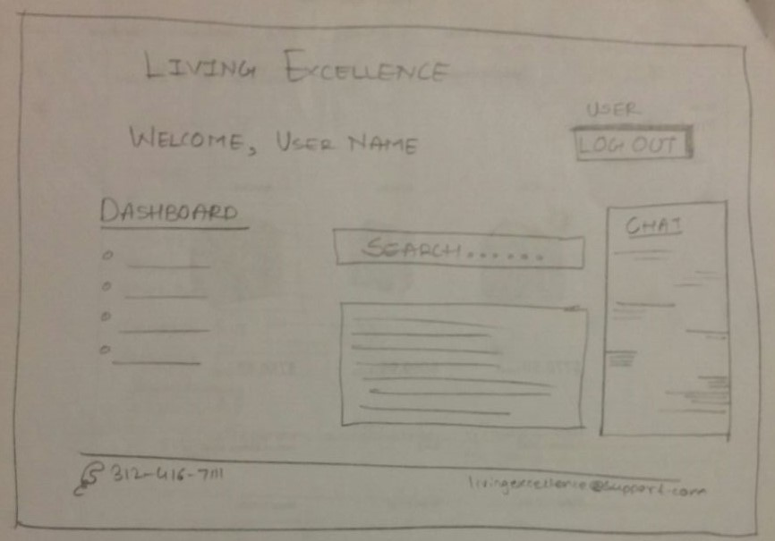

8. The user suggested that, if a user is an owner then after submitting the login details, the owner will be able to logged in to his own account.

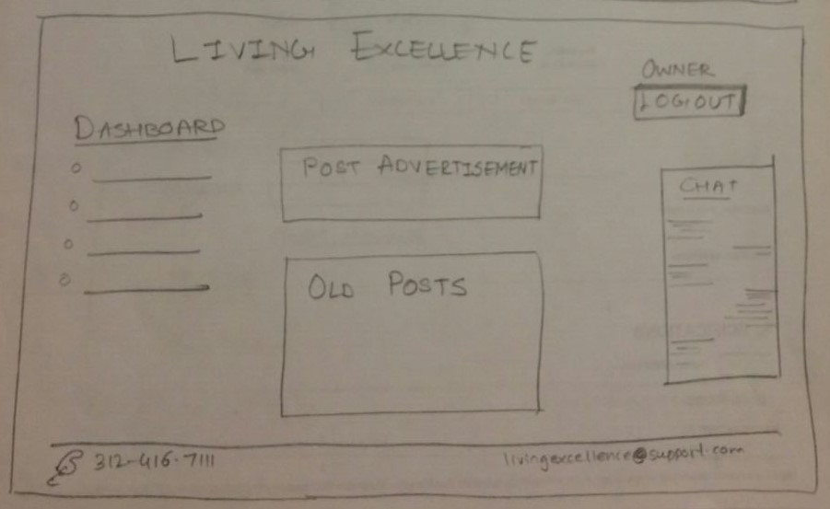

9. Miss Muhammad suggested that if the user wants to logout from his account, then she would create a logout button on the homepage or dashboard page of the user account.

10. At last Ajeenah Muhammad indicated that once the user clicks on the logout button, user will be redirected to the login page.

**SUGGESTIONS RECEIVED FROM USER AJEENAH MUHAMMAD:**

Ajeenah Muhammad suggested to include a search button on the user page so that if a user wants to search an apartment, the user can easily find matching property accordingly. Ajeenah liked the initial home screen of the interface which had two login options namely for the normal user and another for the owner or agent.

**User 2:**

**Persona of the user**

Name: Juan Quintana

Age: 42

Nationality : Spain

Job: Product Analyst

Language used for conversation: English

Juan Quintana is the Product Analyst for Credence Systems Pvt. Ltd. located in West Eerie,Downtown Chicago. He has been working as a Product Analyst from past 7 years in above mentioned multinational company. He has created many prototypes for the products initially. He’s running his own startup in Spain as well. Hence, I finalized Juan Quintana as an example for performing the Contextual Inquiry after inerviewing many random users.

**GOAL:** Juan Quintana as a user was asked to create a Login and Sign-up page using the low fidelity prototype (paper prototype) for the “Living Excellence – Amenities you deserve; lease rates you will love”.

**STEPS:**

1. The user suggested that he would click on the “Login/Sign Up” button in the interface.

2. The user suggested that he would create a common login page for user and owner.

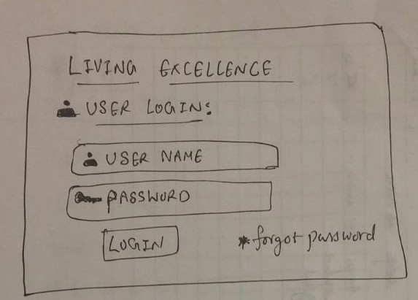

3. The user suggested that he would create a common Sign up page for user and owner both.

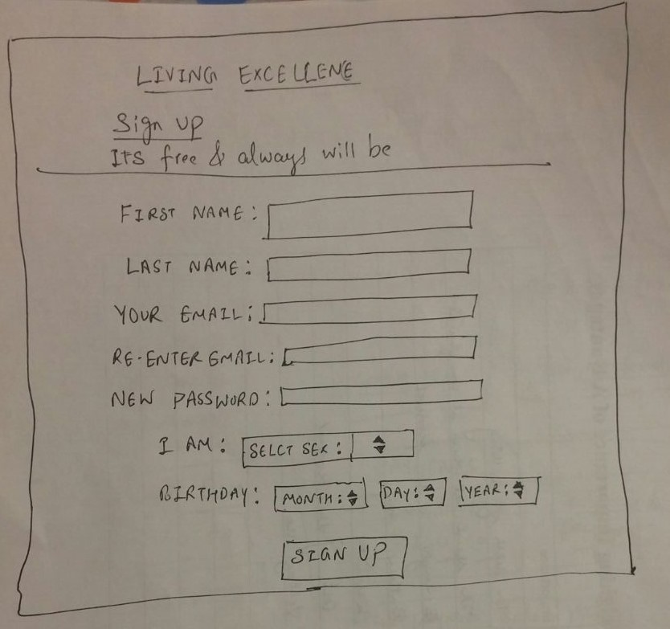

4. The user suggested that user would be signed in successfully after entering the right credentials.

5. The user suggested that website user would be logged in to his or her own account from the login page after clicking the login button and entering the username and password.

6. The user suggested that user would be logged in to user account and owner would be logged in to owner account respectively.

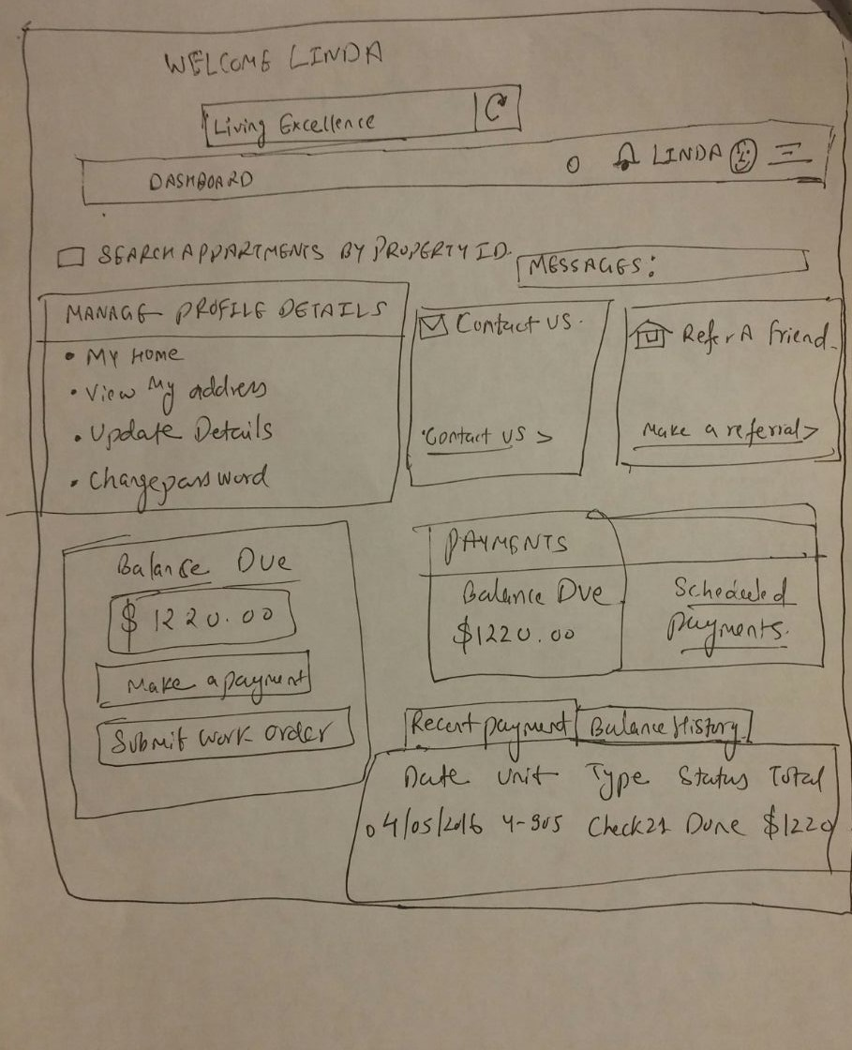

7. The user suggested that he would perform actions like manage account, post requirements and feedback etc. from the user dashboard page.

8. Next, the user suggested that he would click on logout button.

9. The user suggested that upon clicking the logout button, user will be logged off from his or her own account.

10. Lastly, the user suggested that after logout from the account, user would be redirected to login/sign-up page.

**SUGGESTIONS RECEIVED FROM USER:**

Juan suggested that the design looks very minimal without any complicated interfaces which makes the interface understandable easily. He also suggested to add the details which would convey the user “The user has been signed up successfully and the user confirmation has been mailed to your created account”.

**CONTEXTUAL INQUIRY VERSION 3**

**User or owner can either Login to their already created account or else Sign-up to create a new account.**

**DESCRIPTION:** The user is asked to Sign-Up for a new account in Living Excellence website and then login to his/her own created account with the following specification. The contextual inquiry is done based on the Living Excellence user interface.

1. Email-id: [rudra28narayan@gmail.com](mailto:rudra28narayan@gmail.com) , [rudra1personal@gmail.com](mailto:rudra1personal@gmail.com)
2. Password: myapartment, apartment123

**STEPS INVOLVED:**

1. The first step involved in the process was to open the Living Excellence website in web browser.

2. Now, the user must click on the Sign Up button on the top right corner.

3. The user must click on the Sign Up button to create new account.

4. The user must enter the credentials provided to him or her to sign-in.

5. The user must click on Sign Up button.

6. The user should now Login to the account using the credentials provided for login.

7. The user must click on the Login button on the top right corner.

8. The user must enter the details to login.

9. The user must search for the logout button.

10. The user must click on logout button.

**User 1:**

**Persona of the user**

Name: Ajeenah Muhammad

Age: 34

Nationality : American

Job: Leasing Agent

Language used for conversation: English

Ajeenah Muhammad is the leasing agent for Prairie Shores Apartments located in South King Drive,Chicago. She has been working as a leasing agent from past 4 years in Prairie Shores. She has created many listings regarding availability of apartments and rooms for Prairie Shores Apartments and posted it in online on the website. Hence, I chose Ajeenah Muhammad as an example for performing the Contextual Inquiry.

**GOAL:** The user was asked to reach the final step in sign Up and then login in the Living Excellence site by providing a dummy account on the site.

**STEPS:**

1. The user was able to type the url in the web browser and opened the website easily.

2. The user didn’t face any difficulty in the next step to search for login/sign-up button.

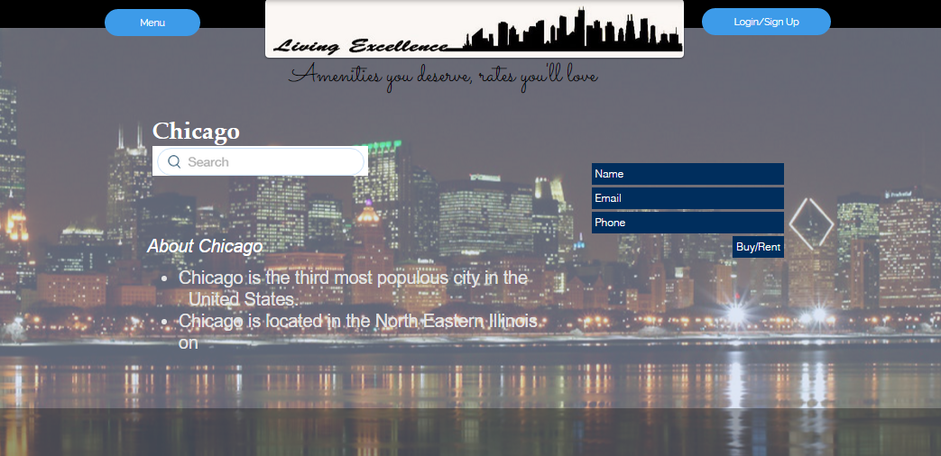

3. The user clicked on the Sign Up button.

4. The user figured it out that user has to fill details and credentials to sign up.

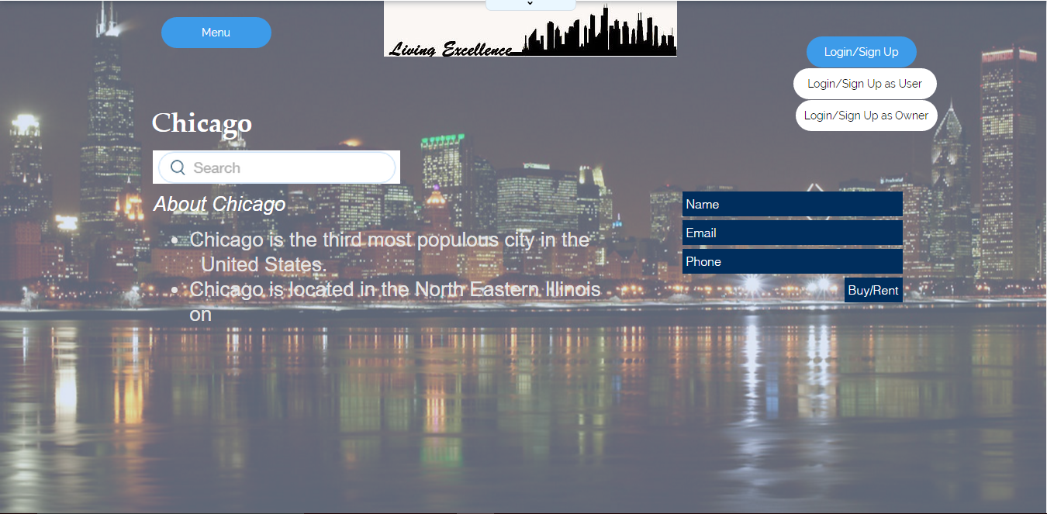

5. After entering the credentials provided to the user, the user clicked on Sign Up button.

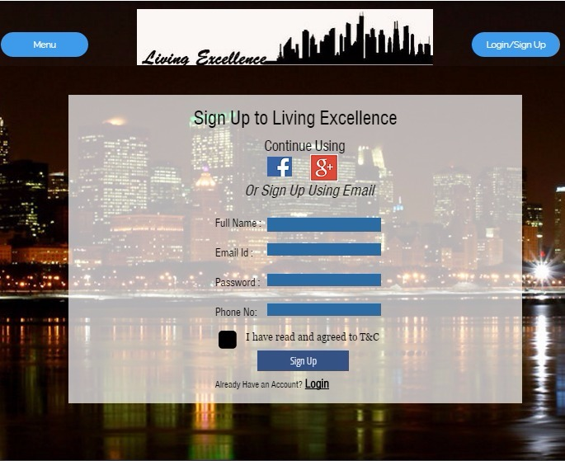

6. The user was able to figure it out the login button after signing in.

7. Hence the user clicked on Login button and entered the user details to login.

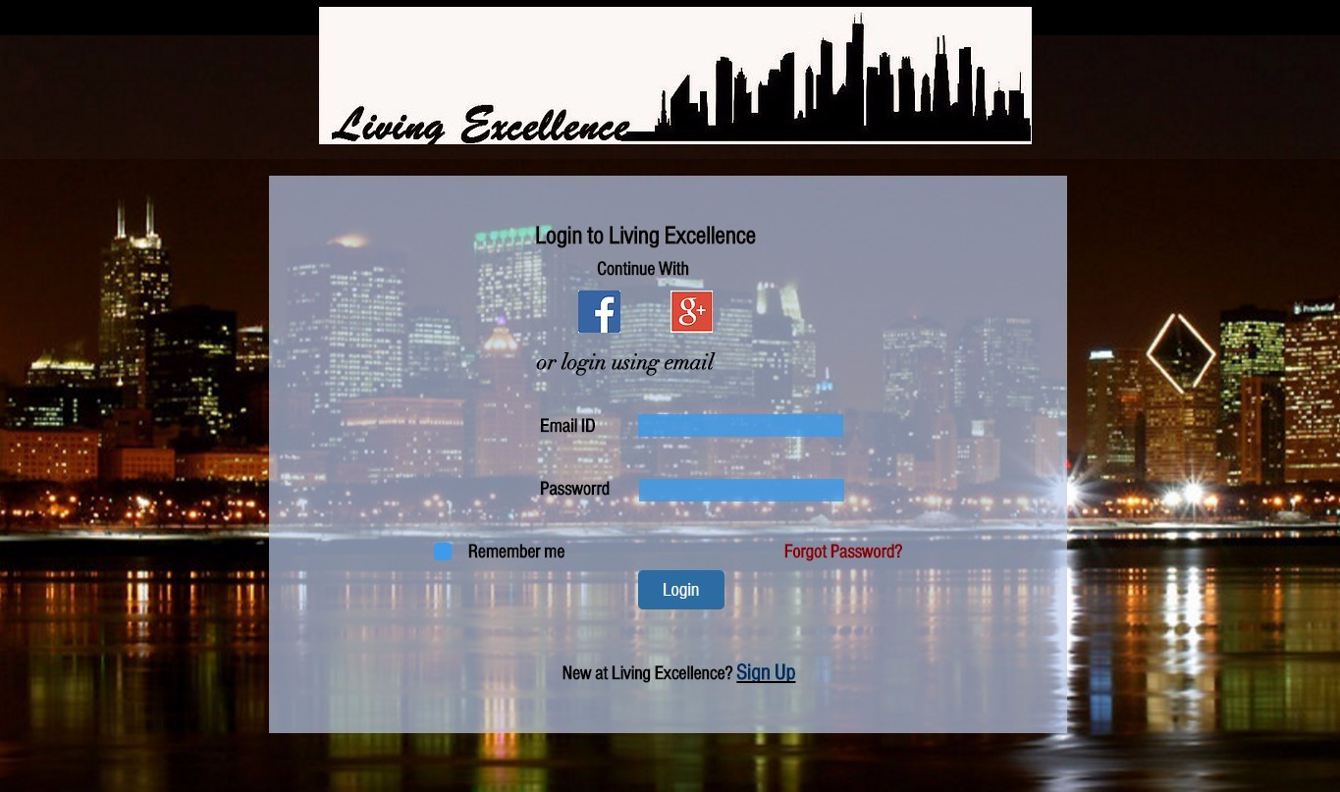

8. The user was able to figure it out the logout button to get logged out from her account.

9. The user clicked on Logout button to reach out of her user account.

**STEPS DONE BY USER IN RIGHT WAY**

The user did all the steps in the process in the right way as expected.

**ISSUES FACED BY USER**

The user didn’t face any issues during the login and entering credentials and completed the given goal successfully.

**User 2:**

**Persona of the user**

Name: Juan Quintana

Age: 42

Nationality : Spain

Job: Product Analyst

Language used for conversation: English

Juan Quintana is the Product Analyst for Credence Systems Pvt. Ltd. located in West Eerie,Downtown Chicago. He has been working as a Product Analyst from past 7 years in above mentioned multinational company. He has created many prototypes for the products initially. He’s running his own startup in Spain as well. Hence, I finalized Juan Quintana as an example for performing the Contextual Inquiry after inerviewing many random users.

**GOAL:** The user was asked to reach the final step in sign Up and then login in the Living Excellence site by providing a dummy account on the site.

**STEPS:**

1. The first step involved in the process was to open the Living Excellence site on the web browser. User performed this task easily.

2. The user was asked to create a dummy account in the website. The user credentials were already provided to the user.

3. The user clicked on the Sign Up button on the top right corner confidently.

4. The user clicked on the Sign Up button and entered the right credentials provided already.

5. The user clicked on Sign Up button.

6. The user was able login to his account using the details.

7. The user clicked on Logout button to get logged out from the dummy account.

**STEPS DONE BY USER IN RIGHT WAY**

The user did all the steps in the process in the right way as expected.

**ISSUES FACED BY USER**

The user didn’t face any issues during the login and entering credentials and completed the given goal successfully.

**HEURISTIC EVALUATION on SATISH’s TASK**

The heuristic evaluation is done on Satish’s task which involves posting a listing or an advertisement for an apartment. The heuristic evaluation is done by considering an existing site [www.airbnb.com](http://www.airbnb.com).

**1. Visibility of the System Status:**

On the page where the user has to post the details of the apartment, the user has to choose the options like the type of the apartment, the type of the room and the number of people it can accommodate in the first page and upon clicking continue, the user will be taken to the next page where he has to choose other details.

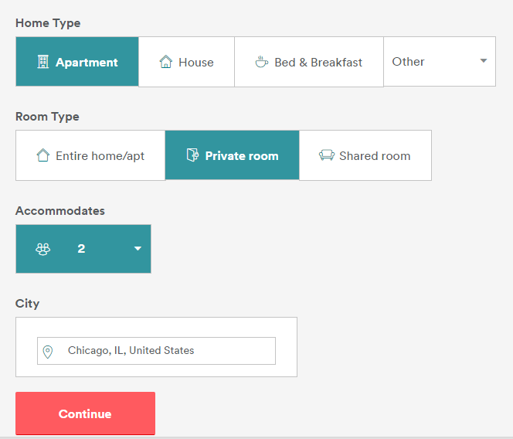

On the second page, there is a list of categories and fields under them, the user is not shown what option he chooses on each screen, this can be avoided by reducing the number of categories and putting them all together in one screen, so that the user can always be aware of the system status.

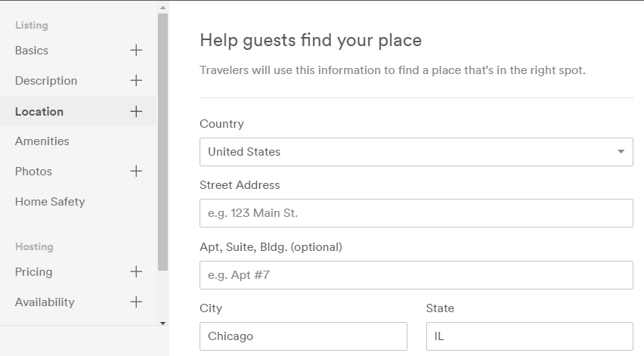

**2. Match between System and Real World:**

The words and terminologies used in the website are not the words that we usually use in the real day to day world. Hence, they are difficult to understand. Instead of using ‘List your Space’ they can use ‘Post your apartment for Sale/Rent’ as it will be easier to understand by the user.

**3. User Control and Freedom:**

There is no option to delete the posting halfway through the ‘Listing’. The users are not allowed the option to delete the posting unless they post the listing completely first, they cannot delete it half way through.

**4. Consistency and Standards:**

Details entered in the first page of post, a listing are needed to be entered again in the second page. There is no consistency or standard followed in this. Also, there is no one proper shape or size for every detail that needs to be filled within the Post a Listing page.

**5. Error Prevention:**

Error Prevention is done properly on the website. The users are prompted with a drop down list with suggestions of the City that they might be looking for. This is done to prevent the users from committing errors.

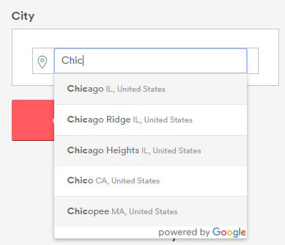

**6. Recognition rather than Recall:**

The autofill feature is not available for the user when the user closes the browser while in the process of posting a listing. This must be enabled.

**7. Flexibility and efficiency of use:**

There are no shortcuts provided for the users. The users have to complete all the mandatory 9 steps to post a listing. The user cannot skip any step in between.

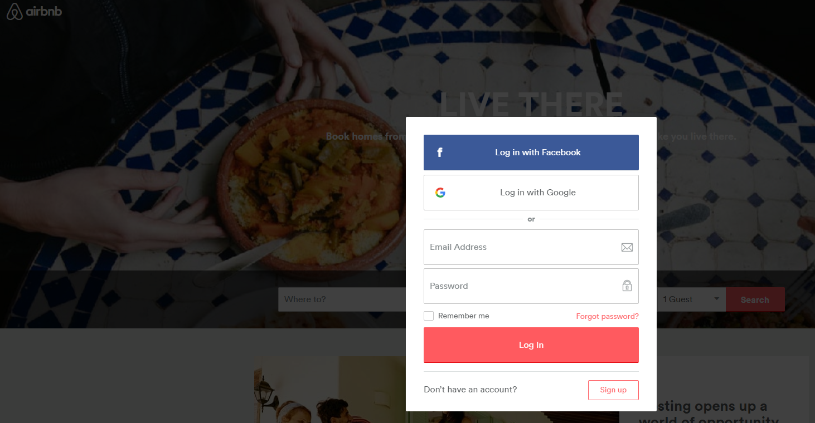

**8. Aesthetic and Minimalist Design:**

The website uses an aesthetic and minimalist design and is very pleasing on the way and follows a certain set of color combinations throughout the website.

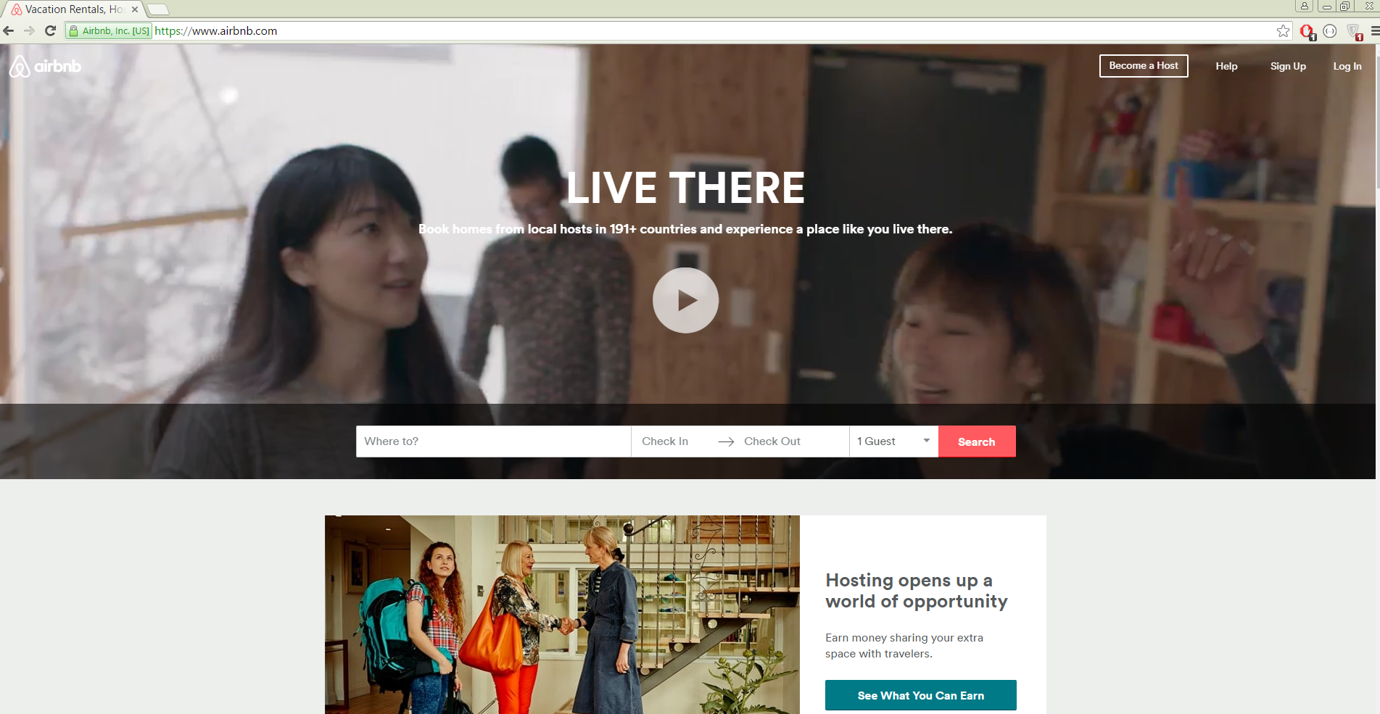

**9. Help users Recognize, Diagnose and recover from errors:**

The fields that are mandatory are not mentioned or denoted. Hence, the users tend to skip through a few fields and end up getting error messages to complete all the required fields.

**10. Help and Documentation:**

Help document is not provided to the user which must be added in order to make the user much clear with the process.

**HEURISTIC EVALUATION on SATISH’s TASK**

The heuristic evaluation is done on Satish’s task which involves posting a listing or an advertisement for an apartment. The heuristic evaluation is done by considering our product Living Excellence. This is the first iteration of Heuristic Evaluation performed on Satish’s tasks.

**1. Visibility of the System Status:**

On the page where the user posts the details of the apartment that he is looking to put up for sale or rent, the user is not shown all the listings that he previously posted on the website, if this is shown, it will be easier for the user to manage his listings instead of having to remember them.



**2. Match between System and Real World:**

The words and terminologies used in the website are not the words that you usually use in the real day to day world. Hence, they are difficult to understand. Words and terms like ‘Localities Servicing’, ‘Alternate Contact’ are all difficult to understand.

**3. User Control and Freedom:**

The user is not allowed the option of editing his personal information on the website. He must be provided an option to edit his personal information.

**4. Consistency and Standards:**

There is very little consistency followed in terms of the words and terminologies used. Words like ‘listing’ and ‘apartment’ are interchanged and used with another in more than one location.

**5. Error Prevention:**

There is no drop down menu or something to help the user from committing errors is missing. The user may enter wrong or inaccurate location or make any typing error in it. This has to be avoided.

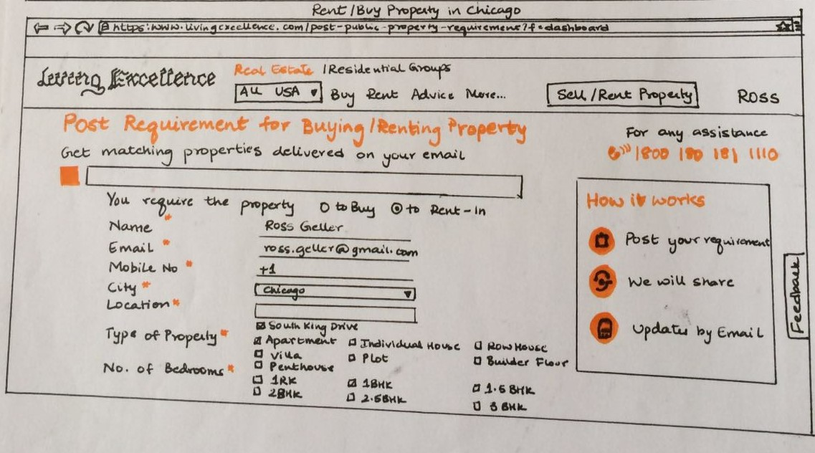

**6. Recognition rather than Recall:**

The fields that have been entered by the user don’t get saved automatically, hence if there is an internet connection loss while entering the data, the data will get lost. This has to be improved.

**7. Flexibility and efficiency of use:**

The users will always be taken to the page where the details of their information will be seen, they are not given the option of going to the post a listing page, in order to do so, they must select the ‘Post a Listing’ option from the Dashboard. This needs to be changed.

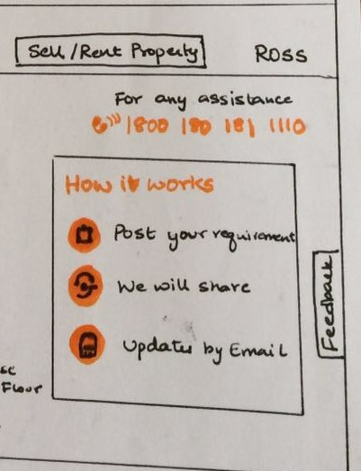

**8. Aesthetic and Minimalist Design:**

The website uses a design that is too complex and not very pleasing on the eye. There are too many data scattered around the web page, which makes it difficult for the user to use the website easily.

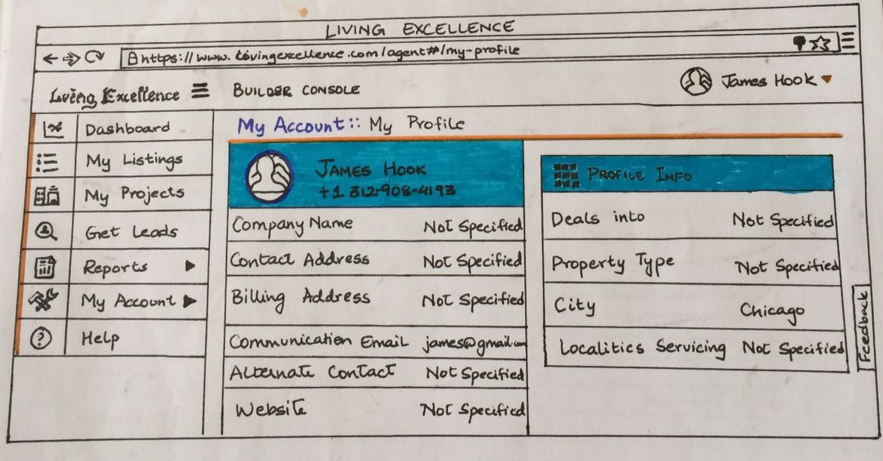

**9. Help users Recognize, Diagnose and recover from errors**

There is no suggestion or drop down list to choose the city or location and similar fields. Hence, there are chances for the users to commit mistakes and there is no proper function to recognize, diagnose and recover from these errors.

**10. Help and Documentation**

Help document is not provided to the user which must be added in order to make the user much clear with the process. There is no option to seek help from the owners for the user to know more about a particular apartment.

**HEURISTIC EVALUATION on SATISH’s TASK**

The heuristic evaluation is done on Satish’s task which involves posting a listing or an advertisement for an apartment. The heuristic evaluation is done by considering our product Living Excellence. This is the second iteration of Heuristic Evaluation performed on Satish’s tasks.

**1. Visibility of the System Status:**

On the page where the user posts the details of the apartment that he is looking to put up for sale or rent, the user is shown all the listings that he previously posted on the website. Similarly, the list of his active listings can also be viewed by the user. This feature was added from the Heuristic Evaluation of the previous iteration.

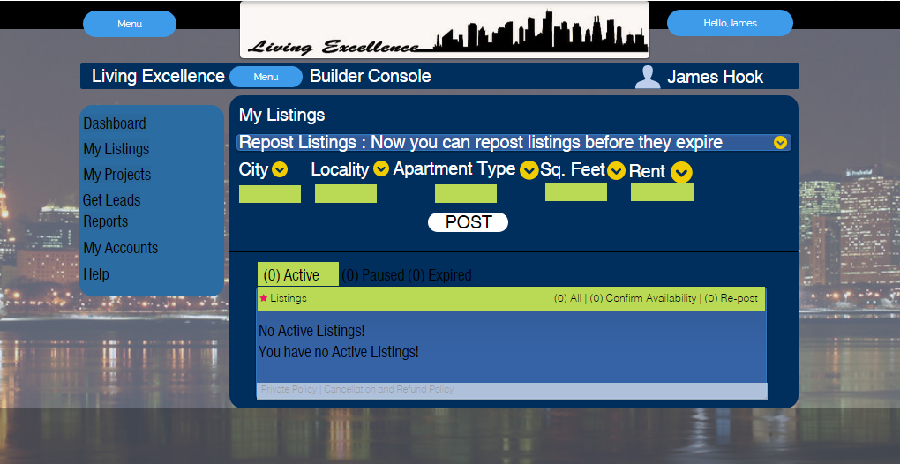

**2. Match between System and Real World:**

The words and terminologies used in the website are the words that you usually use in the real day to day world. Hence, there is a very good match between the system and the real world.

**3. User Control and Freedom:**

The user is provided with an option of editing his personal information on the website. This feature was added from the Heuristic Evaluation of the previous iteration.

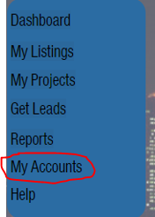

**4. Consistency and Standards:**

The interface is very consistent and follows one particular standard. It uses only a certain set of colors throughout and uses the same set of words in every page.

**5. Error Prevention:**

There is a drop down menu to help the user by providing suggestions while he is filling the fields of City, Locality etc. The user may enter wrong or inaccurate location or make any typos in it. This will be avoided if he is provided with the option of selecting these from a drop down list.



**6. Recognition rather than Recall:**

The fields that have been entered by the user gets saved automatically. The user can also view all the listings that he has already posted on the website. He can view all his apartments under active listings.

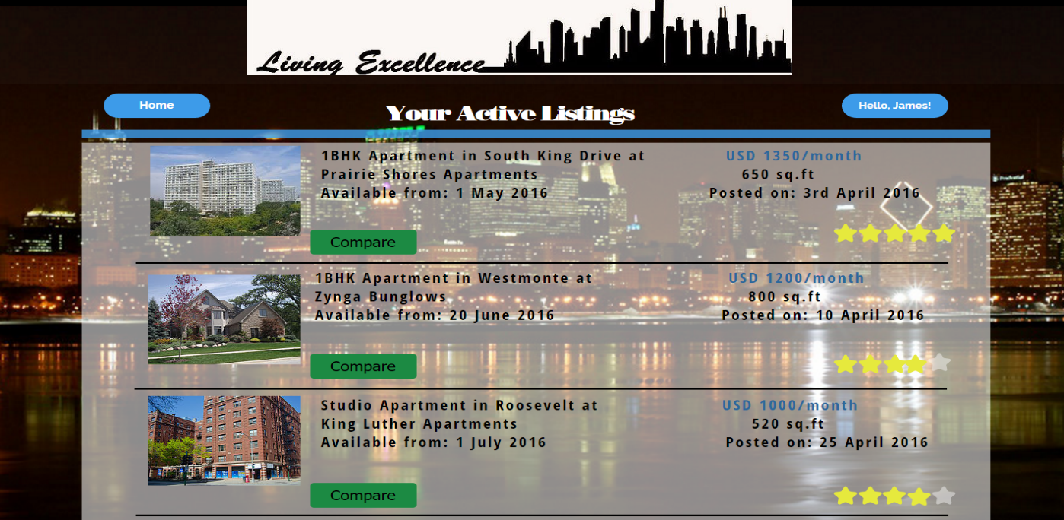

**7. Flexibility and efficiency of use:**

The users are provided the option of selecting the list of his active listings right from the page where they can post a new listing. By doing so, they can efficiently view the list of their active listings.

**8. Aesthetic and Minimalist Design:**

The website uses an aesthetic and a minimalist design, and is very pleasing on the eye. Only a certain set of colors are used which makes for a very good visual experience.

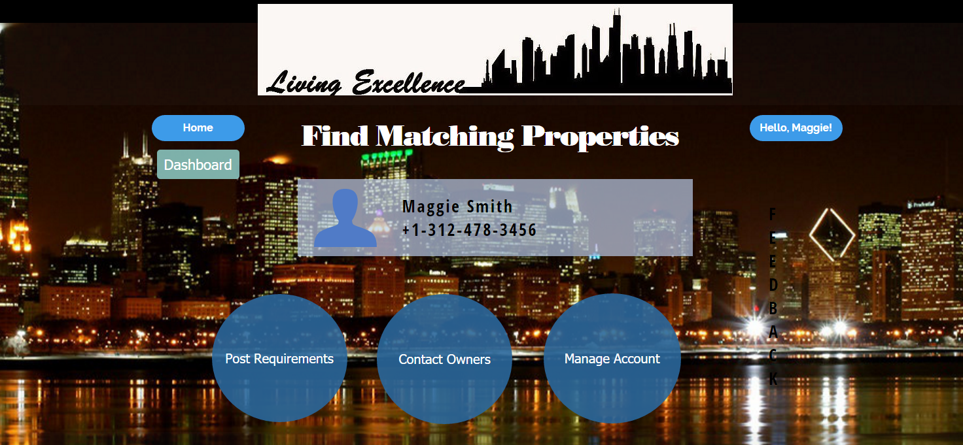

**9. Help users Recognize, Diagnose and recover from errors:**

There is a suggestion or drop down list to choose the city or location and similar fields. Hence, the chances for users to commit mistakes is reduced majorly and in this way, the users can recognize, diagnose and recover from these errors easily.



**10. Help and Documentation:**

Help document is provided to the user to help the users with any doubts in the interface. There is also an option to seek help from the owners for the user to know more about a particular apartment. These are provided with the help of unique features like feedback and live chat.

